A pictorial representation of how quick sort will sort the given array
Let's consider an array with values {9, 7, 5, 11, 12, 2, 14, 3, 10, 6}
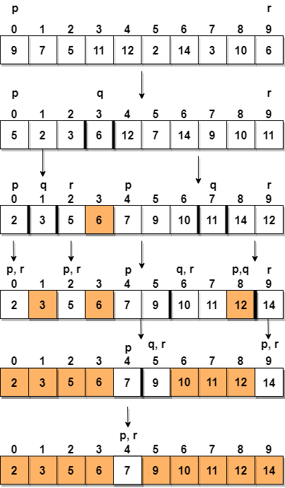

Implementing Quick Sort Algorithm
// simple C program for Quick Sort
# include <stdio.h>

// to swap two numbers
void swap(int* a, int* b)
{
int t = *a;
*a = *b;
*b = t;
}

/*
a[] is the array, p is starting index, that is 0,
and r is the last index of array.
*/
void quicksort(int a[], int p, int r)
{
if(p < r)
{
int q;
q = partition(a, p, r);
quicksort(a, p, q);
quicksort(a, q+1, r);
}
}

int partition (int a[], int low, int high)
{
int pivot = arr[high]; // selecting last element as pivot
int i = (low - 1); // index of smaller element

for (int j = low; j <= high- 1; j++)
{
// If current element is smaller than or equal to pivot
if (arr[j] <= pivot)
{
i++; // increment index of smaller element
swap(&arr[i], &arr[j]);
}
}
swap(&arr[i + 1], &arr[high]);
return (i + 1);
}

// function to print the array
void printArray(int a[], int size)
{
int i;
for (i=0; i < size; i++)
{
printf("%d ", a[i]);
}
printf("\n");
}

int main()
{
int arr[] = {9, 7, 5, 11, 12, 2, 14, 3, 10, 6};
int n = sizeof(arr)/sizeof(arr[0]);

// call quickSort function
quickSort(arr, 0, n-1);

printf("Sorted array: n");
printArray(arr, n);
return 0;
}

A pictorial representation of how merge sort will sort the given array.
